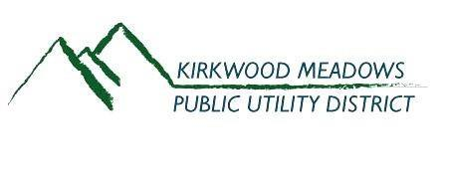
December 2023
Featured Articles

The Future of KVFD Community Forum
Cal Recycle – Solid Waste
Wastewater Treatment Plant Repair and Rehabilitation
November 2023 District Election

The Future of KVFD Community Forum
THE FUTURE OF KVFD
Update | Education | Dialogue
KMPUD's Fire/EMS Temporary Advisory Committee (TAC) invites you to
attend a Community Forum to discuss the
Future of Kirkwood Volunteer Fire Department
DECEMBER 28, 2023
3:45-5:30PM
REDCLIFFS Club Room
Hosted by: KMPUD FIRE/EMS ADVISORY COMMITTEE
Click here to RSVP by 12/21/23

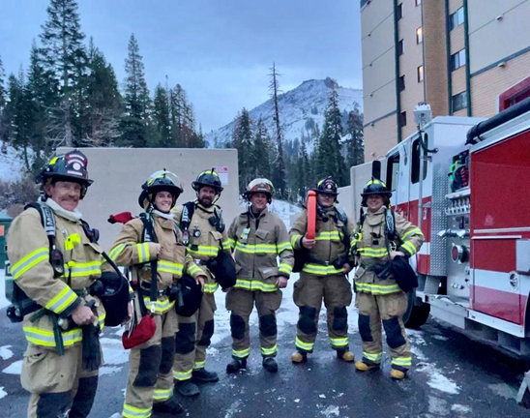

About KMPUD Fire/EMS TAC:
In August, and in efforts to find a solution to the fire department situation,
the KMPUD Board established a committee to gather information from the
community about what levels of service the community wants from a fire
department and what they are willing to pay. This committee consists of
11 individuals who represent a cross section of perspectives from our community.

A Note from Cal Recycle
Preventing Food from Reaching the Landfill
Californians throw away nearly 6 million tons of food scraps or food waste each year. This represents about 18 percent of all the material that goes to landfills. For California to reach its goal of 75% source reduction, recycling and composting, food waste must be addressed.
DID YOU KNOW?
*Across the entire food
production and
consumption
chain, up to 40% of all food in the United States never gets eaten. This translates
to $218 billion lost.
*From farm to fridge, more food is wasted in our
homes than any other
part of the supply chain.
*Across the supply chain, anaverage of 1,250 calories a day is wasted for every
American, adding up to
more than 400 pounds of wasted food a year per
person.
*Each year, the average
family of four wastes an
average of 1,000 pounds of food at home, resulting at least $1,500 lost.
Source: Natural Resources Defense Council
California’s new Mandatory Commercial Organics Recycling law requires businesses to recycle their organic waste. The links below provide more information on food waste management as well as examples of how various business groups and public entities are managing food waste. However, everyone has a role in saving resources and wasting less food. The following suggestions can be useful at your home or vacation location.
Creative food rescue projects like the UglyFruitAndVeg Campaign work to save healthy fruits and vegetables from becoming waste. Rather than throwing away excess food, find ways to manage it more thoughtfully, such as working with groups to ensure that it goes to disadvantaged people, and composting for soil restoration. To further educate the public about food waste, the Natural Resources Defense Council and the Ad Council have initiated a food waste reduction campaign known as Savethefood.com. Their web site offers a complete media kit with posters, videos, social media postings, and more.
Cal Recycle recently conducted two workshops in support of a proposed Food Waste Prevention and Rescue grant program; follow the progress of that program. And has been working to reduce food waste since at least 2002, when its predecessor agency conducted a Food Diversion Summit.

Wastewater Treatment Plant Repair and Rehabilitation

We are pleased to announce the District has received a USDA Rural Development loan and has awarded KG Walters Construction Company the contract to complete the improvements to the Wastewater main treatment building, mechanical components, and electronic systems.

The improvements to the existing wastewater treatment plant (WWTP) will be within the treatment plant site, with the majority being confined to inside the existing building. The only exterior improvement will be the installation of a roof canopy over an existing tank immediately adjacent to the building.

The original WWTP built in the 1970s was upgraded in 1982 with a new treatment building and membrane bioreactor (MBR) treatment system. These structures and support facilities have suffered the effects of age and harsh winters for nearly 40 years and, during the last several years, the WWTP has experienced operational problems due to aging equipment and deterioration of the buildings.

In 2018, a Feasibility Study was completed by Stantec Consulting Services Inc. that investigated alternatives for improvements to the existing KMPUD WWTP.

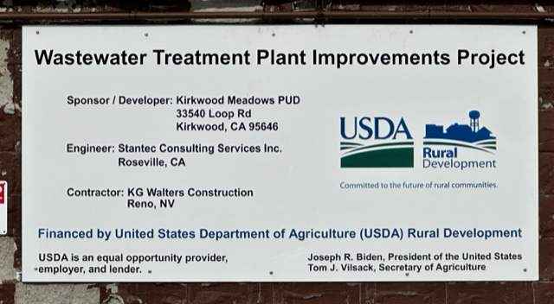
.

Work on the project has recently begun and is scheduled for completion in late 2025.

KMPUD New Board of Directors
Now with the elections completed, during the December 8th Board Meeting, the Directors voted on Board of Directors Titles. The results are Robert Epstein as President, Doug Mitarotonda as Vice President, Peter Dornbrook as Secretary, Chris Tucher as Assistant Secretary, and John Schroeder as Treasurer.

Ash Collection at Kirkwood
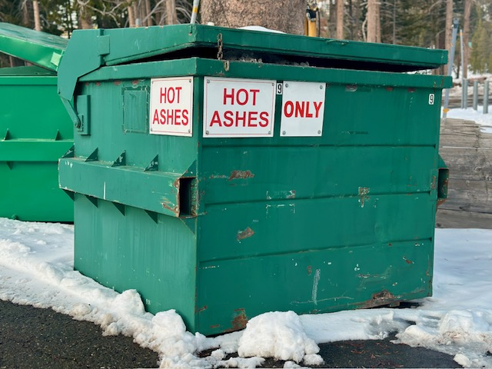
With the increase of winter occupancy in the valley, this is a good time to remind those who burn wood and/or accumulate ashes to always place ash in the “Ash Only” designated container located at the main dumpster pad on Loop Road.
Do not dispose of ashes in regular trash bins anywhere in Kirkwood.
Embers can remain hot for a very long time and never assume ashes are out or transport ashes in paper or plastic containers.
For more information about Ash Disposal, please call the District at (209) 258-4444.

Kirkwood Meadows Public Utility District is an equal opportunity provider and employer.

