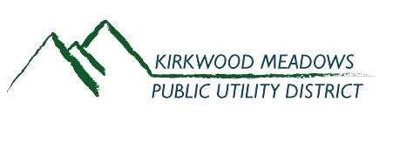

October 2023
Featured Articles
KMPUD Board of Directors Election
Winter Preparations
Fireplace Ash Disposal
Prevent Chimney Fires

KMPUD Board of Directors Election

The Kirkwood Meadows Public Utility District (KMPUD) Board of Directors Election will be held on Tuesday, November 7, 2023. This election is for two Directors for Seats 1 and 2 for term of office 12/1/23-12/03/27.
All registered voters in Kirkwood will receive a ballot in the mail. Whether you live on the Amador County or the Alpine County side of the Valley, ballots can be returned to the Alpine County Clerk via mail or at the ballot drop box located at the Alpine County Clerk’s Office at 99 Water Street in Markleeville, CA. Ballots that are returned by mail must be postmarked on or before Election Day. Ballots received after Election Day with a valid post mark will be counted and added to the final tally. Voters can also vote in person at the Alpine County Clerk’s Office on election day. Polls will be open from 7:00 AM to 8:00 PM. The Alpine County Clerk handles all KMPUD elections. Please do not return your ballot to Amador County. If you would like to register to vote, follow this link: https://www.registertovote.ca.gov/
For more information about the election and candidates please go to https://www.alpinecountyca.gov/388/Election

______________________________________________________________________________
Winter Preparations
Fall is in the air and now is the time to get your house ready for winter before the snow flies. Below are some other important items which may need to be on you winter prep check list.
- Know where your water shut-off is and ensure that it is accessible.
- Give your heating system a test run so you know it will work properly when you need it.
- Replace the filter on your furnace.
- Make sure chimneys and fireplaces are cleaned.
- Replace batteries in smoke and carbon monoxide detectors.
- Buy an extra snow shovel and put it in an accessible place.

Fireplace Ash Disposal
The District, in cooperation with ACES Waste Services, provides an Ash Bin as a courtesy to our customers who need to dispose of ashes produced by wood stoves and fireplaces safely. The purpose of the Ash Bin is to prevent fires in other dumpsters which are dedicated solely for disposal of household waste. In the past, improper disposal of ashes has caused numerous fires at the dumpster pad, trash chute rooms and even the ACES dump truck. Such events pose a serious fire threat to homes and could cause a wildland fire.
The Ash Bin is located at the KMPUD Dumpster Pad adjacent to the Wastewater Treatment Plant on Loop Road and is available 24-hours a day. This bin is for ashes only. Please do not dispose other items in this dumpster including bags, boxes or bins used to transport the ashes, as that also poses a fire threat. Also please ensure that the Ash Bin is closed after use so that embers do not travel to the surrounding area. Thank you!
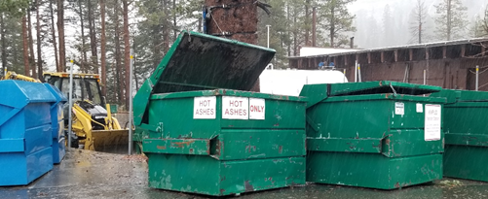

Prevent Chimney Fires
Just a friendly reminder, It’s important to have your fireplace or wood stove professionally cleaned and inspected. The number one cause of chimney fires is creosote build-up. Creosote forms and coats chimney walls when smoke and vapor condense as they move from the hot fireplace to the cooler chimney. If the temperature in the chimney gets hot enough, and creosote build-up is thick enough, the creosote can catch fire and spread throughout the chimney.
Tips to help prevent chimney fires:
- Have your fireplace or woodstove, chimney and venting system inspected and cleaned annually.
- Install a chimney thermometer to monitor the temperature of your chimney.
- Only burn seasoned hardwood that has been cut, split, and dried for at least six months.
- Follow the manufacturer’s instructions for use of your fireplace or wood stove.
- Employ clean burning techniques. Low-temperature, slow-burning fires produce more smoke and leave behind more unburned combustible material that hardens into creosote on the chimney walls. On the other hand, hot, fast-burning fires leave behind less smoke, vapor, and unburned material, so little to no creosote forms.
- Always extinguish the fire before going to bed for the night.
- Keep a fire extinguisher near your fireplace or wood stove.
How to determine if you're having a chimney fire:
If your chimney thermometer reads above 450°F, you're at risk for having a chimney fire. If you do not have a chimney thermometer, look for other tell-tale signs. A glowing red chimney pipe is an indication that, at best, your chimney is too hot and at worst, that you have a chimney fire. One of the most common signs of a chimney fire is sparks or flames emitting from your chimney. The sound the fire makes is important as well. If you hear a sound like a jet engine or a freight train coming from inside the chimney that indicates a possible chimney fire.
What to do if you think you're having a chimney fire:
- Don't panic!
- Call 911 and evacuate your family and pets from the building.
- Close dampers. If the stove is airtight, keep the door closed to cut off the air supply to the firebox.
- Wait in a safe location for the fire department to arrive.
Kirkwood Meadows Public Utility District is an equal opportunity provider and employer.

